GIT Installation Guide
Draft copy

 |  | Prepared by:: Gary Zhuo  Filename:  Version:

Document Information
Project Name:
Project Manager: |  | Document Version No: | 1
 |  | Document Version Date:
Prepared By: | Gary Zhuo | Preparation Date: | 2010-11-3
Distribution List
From | Date | Phone/Fax

To | Action* | Due Date | Phone/Fax
* Action Types: Approve, Review, Inform, File, Action Required, Attend Meeting, Other (please specify)
Version History
Ver. No. | Ver. Date | Revised By | Description | Filename
0.1 | 2010-11-03 | Gary Zhuo | Draft version | Installation and Configuration Guide for GIT.doc
0.2 | 2010-11-15 | Steve Wong | Specify the installation version of Git and GitExtension | Installation and Configuration Guide for GIT.doc
0.3 | 2011-02-07 | Steve Wong | Update GIT Setup CR/LF setting | Installation and Configuration Guide for GIT.doc
0.4 | 2011-02-09 | Steve Wong | Update download path of GITExtension | Installation and Configuration Guide for GIT.doc
0.5 | 2011-12-05 | Steve Wong | Update SSH key generation criteria (need to be all lower case) | Installation and Configuration Guide for GIT.doc
0.7 | 2012-5-24 | Gary Zhuo | Update the SSH key upload procedure | Installation and Configuration Guide for GIT.doc

Proprietary Notice

The information disclosed in this document is the property of OOCL.
No exploitation or transfer of any information contained herein is permitted in the absence of an agreement with OOCL, and neither the document nor any such information may be released without the written consent of OOCL.

Table of Contents
1 Introduction 5
2 Intended Audience 5
3 Git Extensions Installation 5
3.1 MsysGit Installation 6
3.2 KDiff3 Installation 14

Introduction
The document will provide the procedures to install the MsysGit and Git Extensions in a PC environment. The major steps are as follows:

- Installing MsysGit (1.6.5.1)
- Installing KDiff3
- Installing Git Extensions (1.9.5)

Intended Audience
The intended audiences are all the developers who intend to use GIT as SCM tool

Git Extensions Installation
Git Extensions is a tool we will use to interface with Git.

Run the corresponding setup program in your region.
For SNT: \\snt\isd\software\Git\GitExtensions195SetupComplete.msi
For HKG, MNL and SHA: \\hkg\isd\Software\Git\GitExtensions195SetupComplete.msi
For ZHA: \\zha\isd\Isd public\Git\GitExtensions195SetupComplete.msi

What follows is a set of screenshots of the server installation portion of the setup. Follow the settings as captured or as identified in the extra notes.

Step 1:
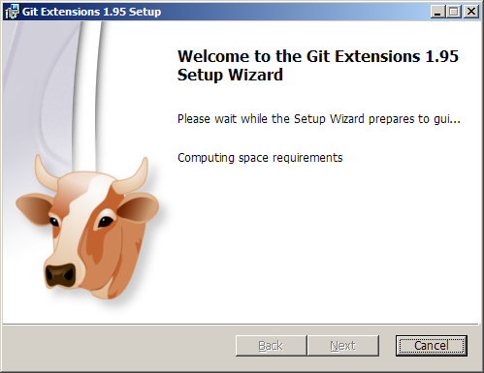

Click “Next >” button to continue the installation.

Step 2:
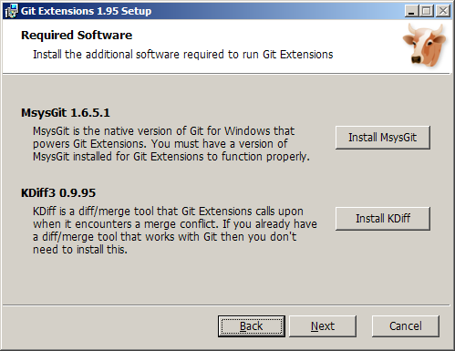

Click on Install MsysGit button to install MsysGit (Reader can skip the section 3.1 – MsysGit Installation if MsysGit has already installed at your local PC)

MsysGit Installation
What follows is a set of screenshots of the server installation portion of the setup. Follow the settings as captured or as identified in the extra notes.

Step 3.1-1:
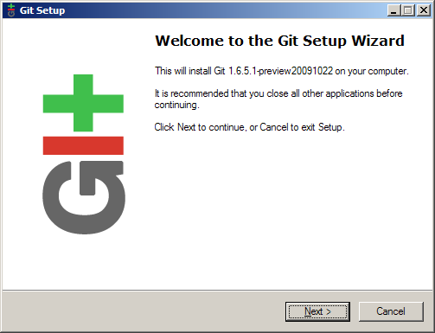
Click “Next >” button to continue the installation.

Step 3.1-2:
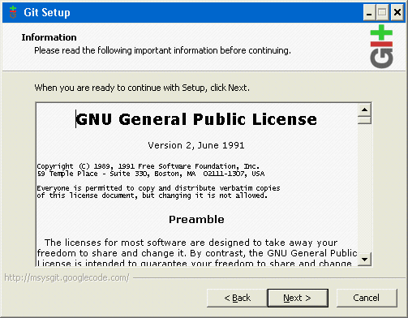
Click “Next >” button to continue

Step 3.1-3:
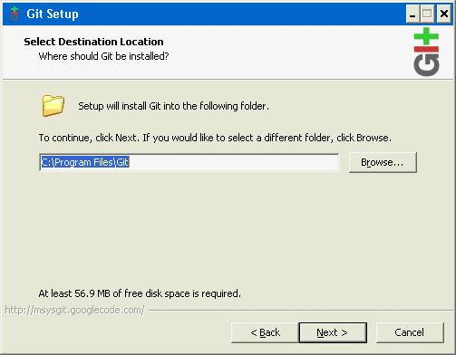
Use the default destination location and click “Next >” button to continue

Step 3.1-4:
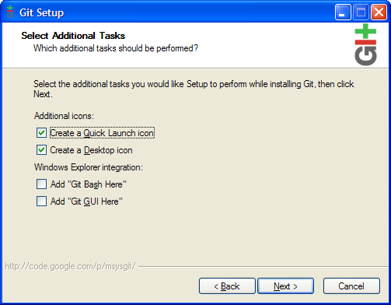
Make your own selection for components and click “Next >” button to continue
We recommend "Additional Icons" and "Windows explorer integration" options be turned off.

Step 3.1-5:
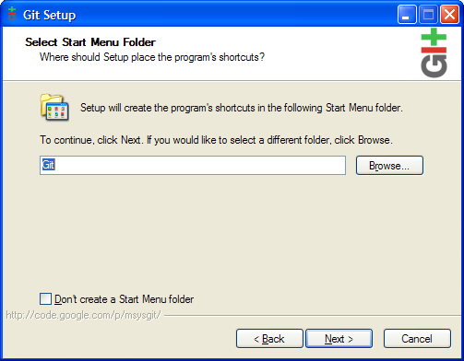
Click “Next >” button to continue

Step 3.1-6:
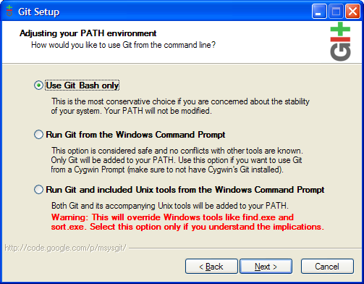
Select “Use Git Bash only” and then click “Next >” button to continue
Step 3.1-7:
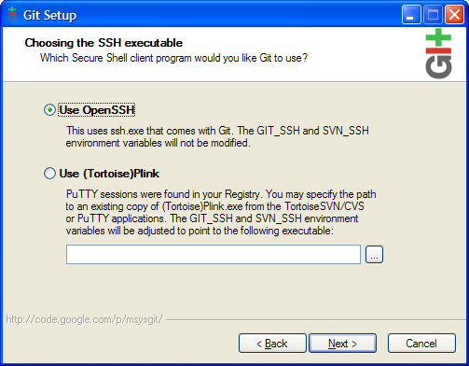
Select “Use OpenSSH” and then click “Next >” button to continue

Step 3.1-8:
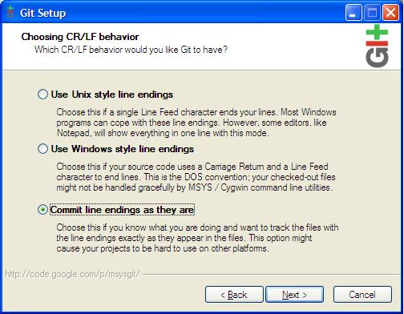
Select “Commit line endings as they are” and then click “Next >” button to continue
Step 3.1-9:
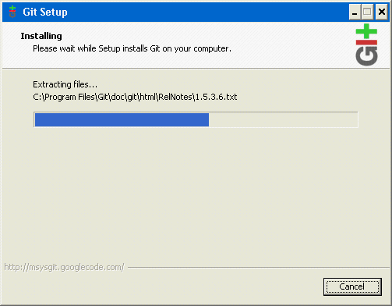
The msysGit will install to your computer. Please wait a few minutes.

Step 3.1-10:
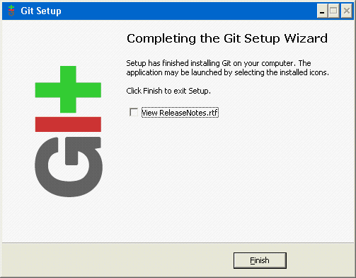
After the installation, you can find a shortcut called “Git Bash” on your desktop.
Step 3.1-10:
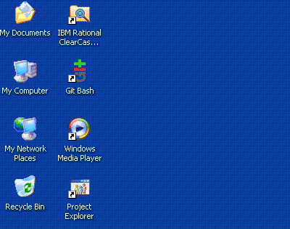
If push/pull/clone activities will sent to the GIT server directly, user need to generate SSH key and request access right.

Please double click “Git Bash” on your desktop and execute “ssh-keygen -t rsa” command. (accept defaults by pressing enters and MUST NOT input the passphrase)

Since we adopt gitolite for access control in OOCL environment, user need to rename the SSH public key (C:\Documents and Settings\<domain id>\.ssh\id_rsa.pub) from id_ras.pub to <domain_id>@<hostname>.pub , Register your SSH public key in our website. GITADMIN will help to handle your request.

NOTE: <domain_id> and <hostname> MUST BE IN LOWER CASE. Please refer to knowledge base for details.
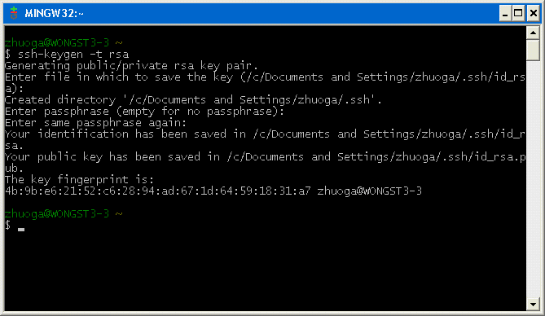

Back to GitExtensions setup windows

Click “Install KDiff >” button to install Kdiff3 (Reader can skip the section 3.2 – KDiff3 Installation if KDiff has already installed at your local PC)

KDiff3 Installation
Step 3.2-1:
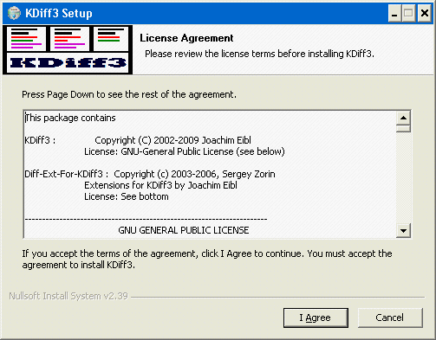
Click “I Agree” button to continue

Step 3.2-3:
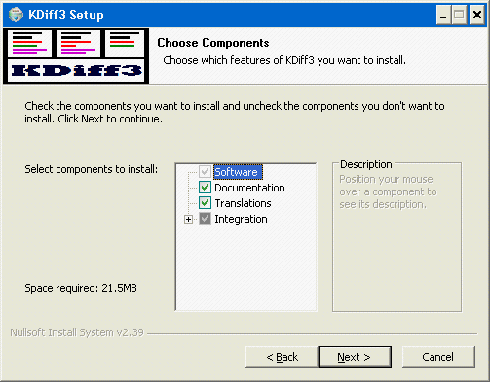
Use the default selection for components and click “Next >” button to continue

Step 3.2-3
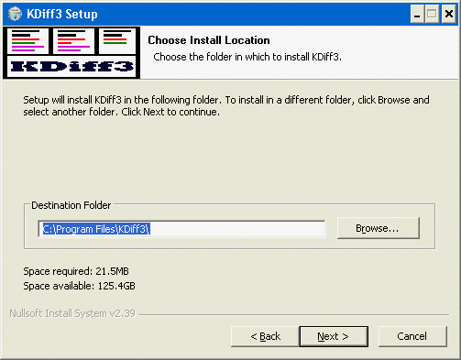
Click “Next >” button to continue

Step 3.2-4:
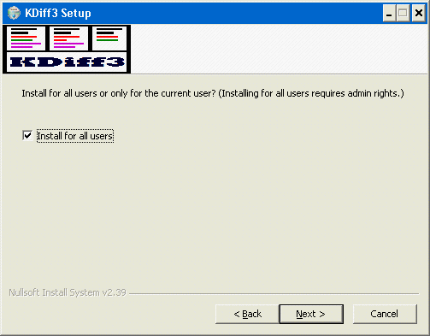
Click “Next >” button to continue
Step 3.2-5:
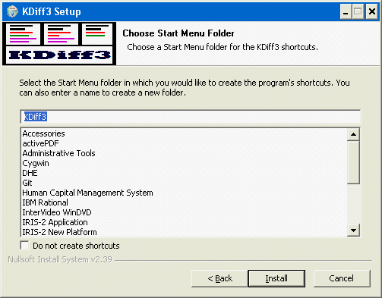
Click “Install” button to continue

Step 3.2-6:
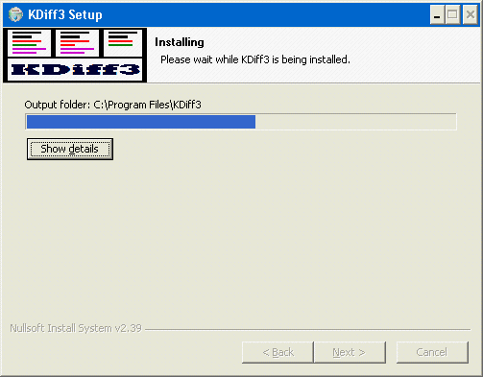
The KDiff3 will install to your computer. Please wait a few minutes.
Step 3.2-7:
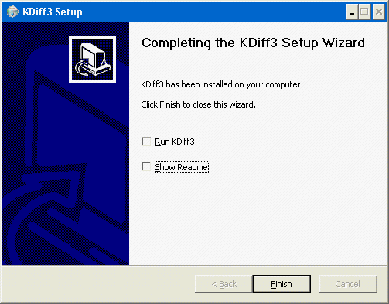
Click “Finish” button.

Step 3:
Back to GitExtensions setup windows
Back to the Git Extensions installation wizard and click “Next” button to continue. (No need to install MsysGit)
Step 4:
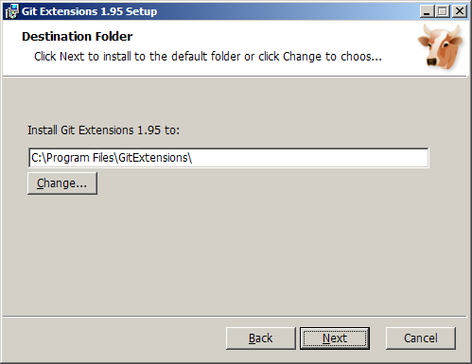
Use the default destination folder and click “Next” button to continue.

Step 5:
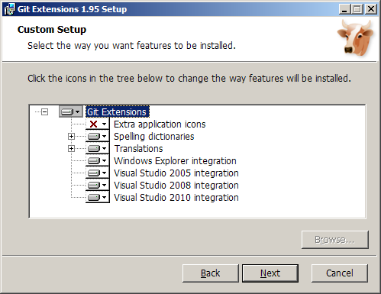
Select the features you want to install and click “Next” button to continue.
Step 6:
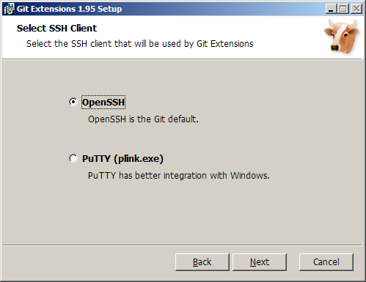
Select “OpenSSH” as SSH client used by Git Extensions and then click “Next” to continue.

Step 7:
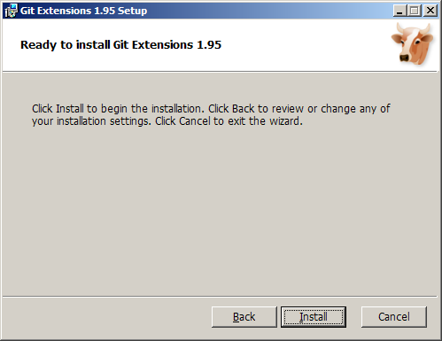
Click “Install” button to start the installation.
Step 8:
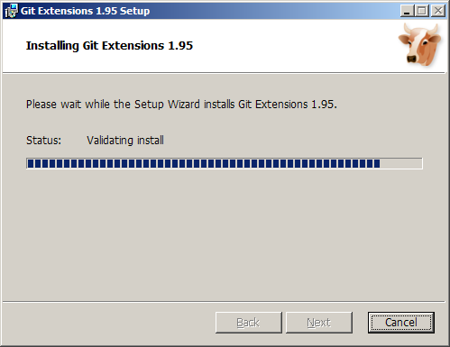
Please wait during the installation

Step 9:
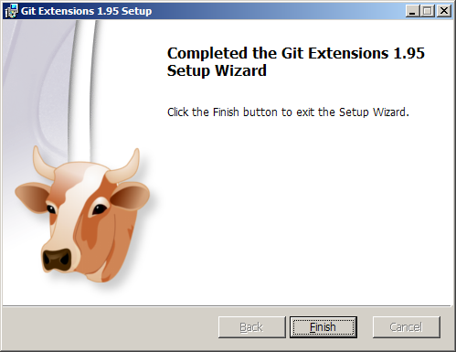
Click “Finish” button to complete the installation. After installation, you can find “Git Extensions” on your desktop.
Step 10:
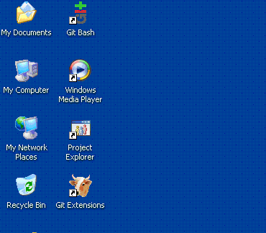

Step 11:
Double click “Git Extensions” to start it and then click “Close” button to cancel the “check for update”
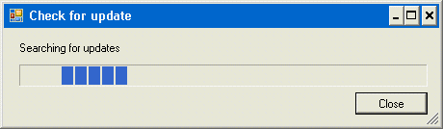

In Git Extensions, click “Plugins” -> “Settings” in menu bar, select “check for updates” and then set “false” to “Enabled (true/false)” setting.
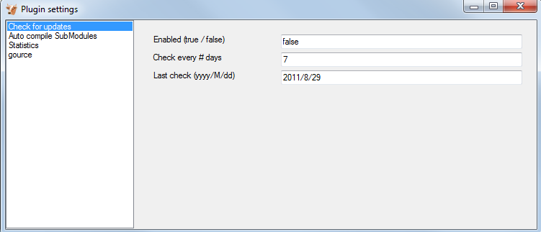
Step 12:
In Git Extensions, click “Settings” > “Settings” in menu bar and navigate to “Global settings” tab. Please input your “User name” and “User email”.

Also, make sure that “Convert CRLF at the end of lines in text files to LF, AutoCRLF” is set to false
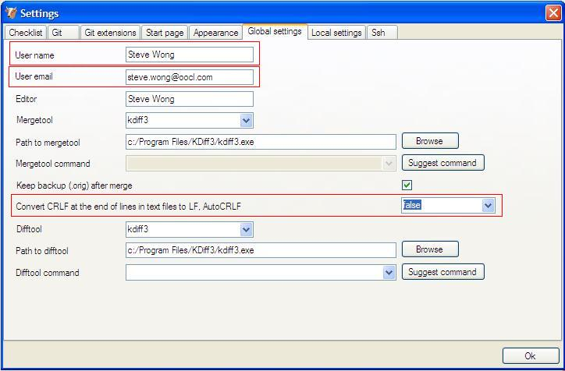
Then, go to “Checklist” tab and click “Save and rescan” button. If all items are highlighted with green colour, your setting is ok.

In Git Extensions, click “Settings” > “Settings”. At the Checklist tab, ensure that “Check settings at startup(…)” at the bottom is unchecked, then click OK
